**WEB PROGRAMING LANGUAGES WEEKLY ACTIVITY 04**

1. **form1.php**

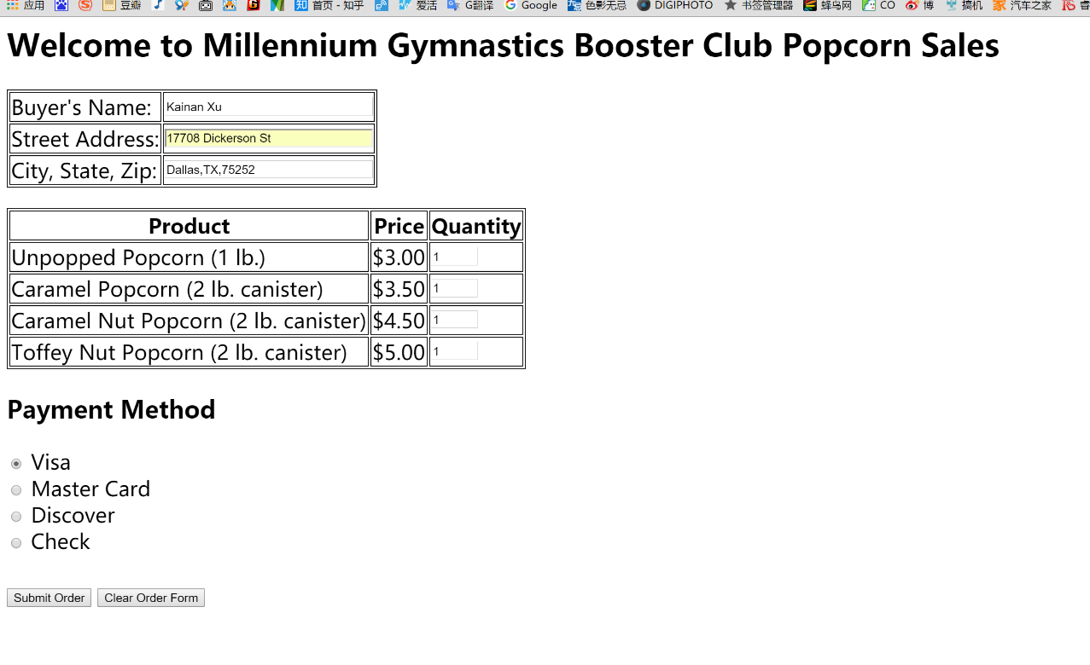

1. **Formlogin.php**

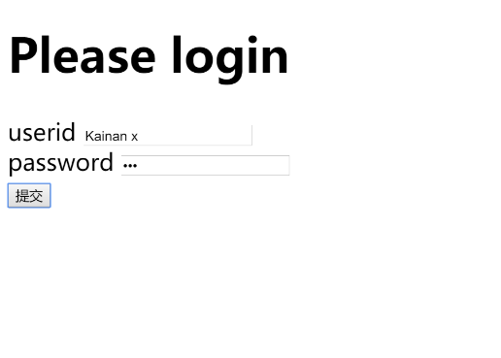

1. **Select.php**

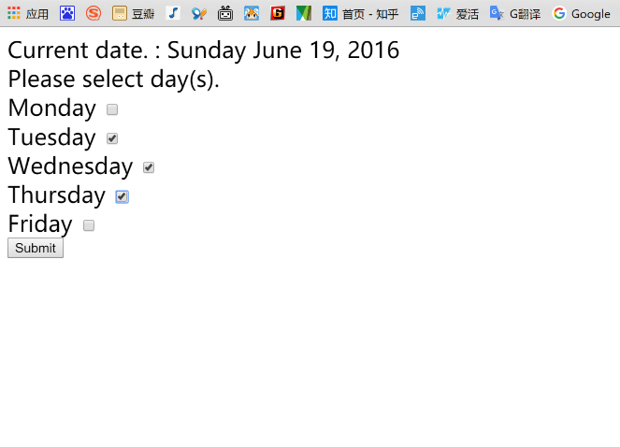

|  |
| --- |
| **This file contains** |
| **Screen shots for weekly activity 04** |